Union assignments

Mandatory
- Refer the code below and comment on size of the given structure considering
  - Structure as union
  - Structure as struct
  - arr
  - uarr

___ Job
{
char name[32];
unsigned short ucount;
float salary;
int workerNo;
char *orgname;
};

___ Job myvar; //could of union or of struct
Struct Job arr[10];
Union Job uarr[10];
ANS:
- Structure as Union
union Job {
char name[32]; // 32 bytes
unsigned short ucount; // 2 bytes
float salary; // 4 bytes
int workerNo; // 4 bytes
char *orgname; // 8 bytes (on a 64-bit system)
};

- Structure as struct
struct Job {
char name[32]; // 32 bytes
unsigned short ucount; // 2 bytes
float salary; // 4 bytes
int workerNo; // 4 bytes
char *orgname; // 8 bytes (on a 64-bit system)
};
- Arr
sizeof(arr) = 10 * 56 = 560 bytes
As mentioned above, the array arr holds 10 elements, and each element is a struct Job with a size of 56 bytes.
So, the total size of arr (an array of 10 structs) is 560 bytes.

- Uarr
sizeof(uarr) = 10 * 32 = 320 bytes
Similarly, for uarr, each element is a union Job, and each union takes 32 bytes.
So, the total size of uarr (an array of 10 unions) is 320 bytes.

- Refer Job datastructure in Q#1 above. Using uarr, perform below operations.
  - Read and store salary
  - Read and store workerNo
Comment on values of output if salary and workerNo are printed in order. Justify your statement.
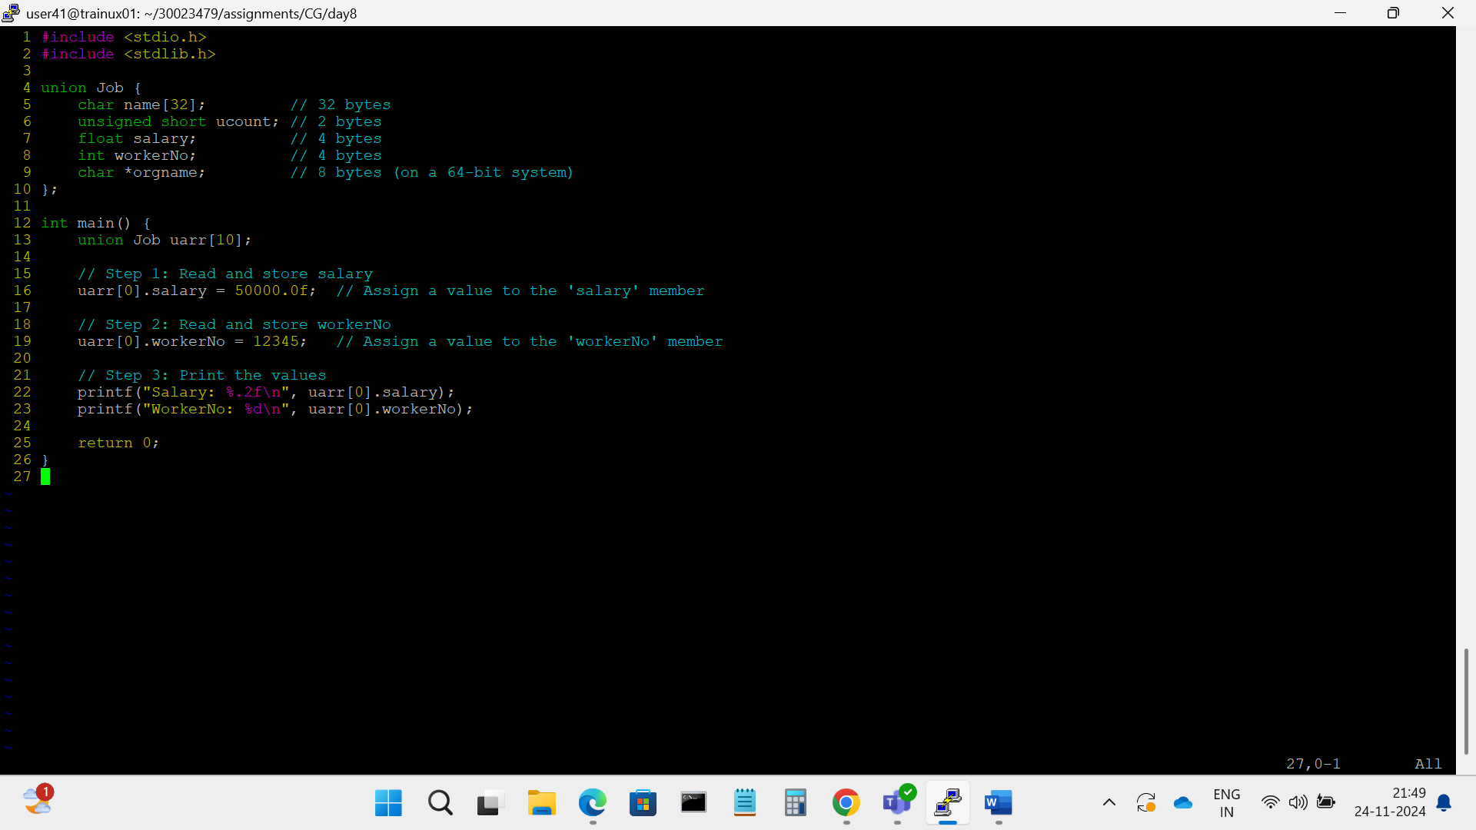
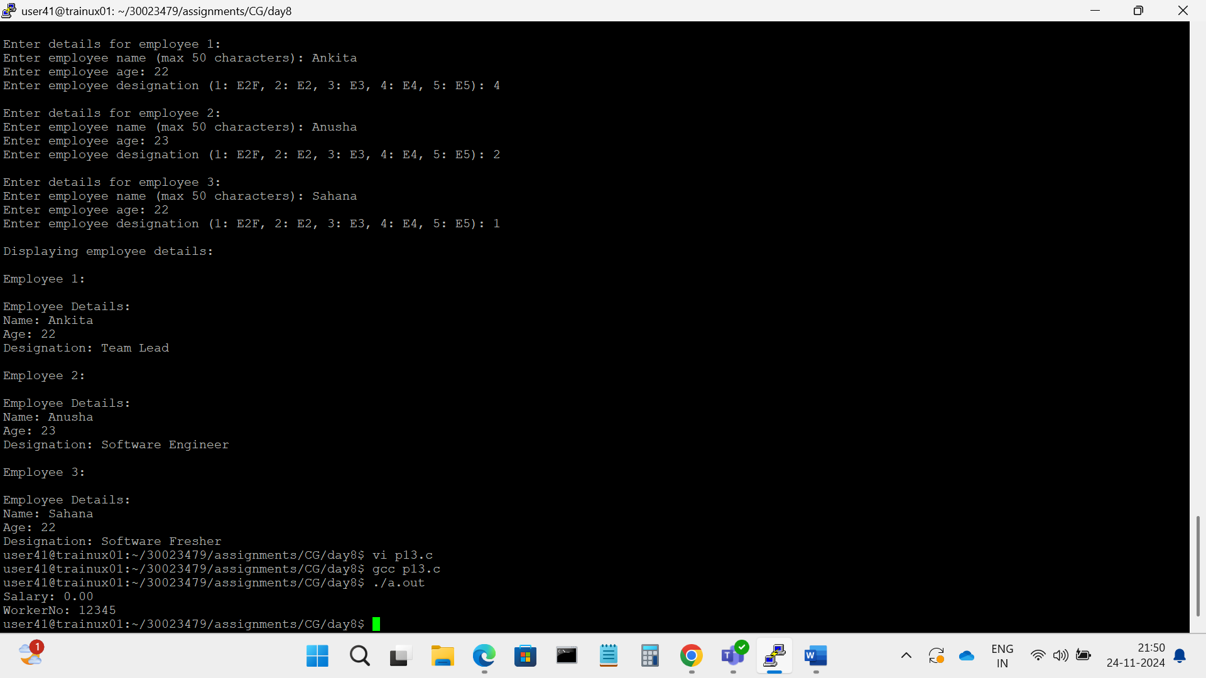
- Memory Overlap: The key takeaway is that in a union, assigning a value to one member will overwrite the other members because they all share the same memory space. This is why we observe the unintended behavior when printing the salary value after storing workerNo.
- Correctness of Output: The output for workerNo is correct, but salary will show an unexpected value (depending on how the integer value 12345 is represented as a float in memory).
4o mini

- Refer Job datastructure in Q#1 above. Assume that myvar is a structure variable. If I need to place 2 bytes (i.e 0x0102) as ucount using a char *ptr then list all possible statements that can be used in _____.
[Let solutions include cases such as
    - using base address of ucount
    - using relative address of ucount w.r.t to base address of myvar]
int main()
{
char *ptr = &myvar;

___________ = 0x01;
___________ = 0x02

}

  - using base address of ucount
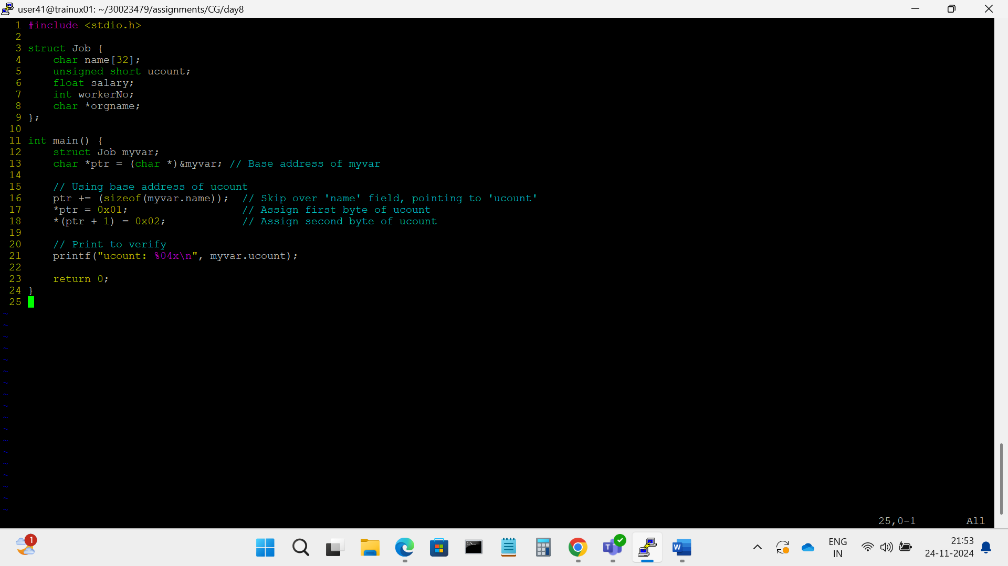
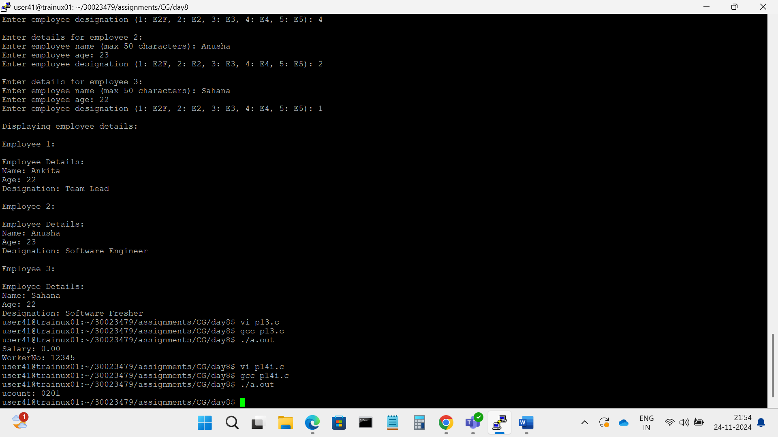

  - using relative address of ucount w.r.t to base address of myvar]
